|  |  |  |  |  |
| --- | --- | --- | --- | --- |
| |  |  | | --- | --- | | Healthy  Whole |  | |  |  | |
| Richard Barnes U1774692 CT2178 / 1718 Introduction to Visual Design.  Web Design Sketch-Book.  April 2018  Web Design BSc |

Table of Contents

The Problem… 3

The Context… 3

The User 4

The Goals… 7

The Competition 8

Styling 10

Wire Framing 13

Mock Up – Desktop, Landing Page 17

Menu Page 18

Desktop -Mac Mock-Up 19

Tab Page 20

Contact Page 21

Mock Up – Mobile 22

Feedback 24

Reflection 24

Bibliography 25

# The Problem…

Healthy Whole Public Limited Company (PLC) are a startup based in Leeds who cater for Vegan’s and Vegetarians who wish to dine on their favorite menus at home without the hassle of cooking or heading out to find table at a reasonably priced restaurant.

Healthy Whole currently don’t own any digital asset including a Website or Mobile App.

The client requires a website which will be the focus of delivery menus, orders, and also gives users access to accounts, promotions and discounts.

# The Context…

The takeaway delivery business is big business, convenient, hassle-free food is on the increase. Competitor research found that Leeds currently doesn’t have a delivery service which provides solely Vegan and Vegetarian dishes.

The “BIG 3” dominate the mass market. Just Eat, Deliveroo, and Hungry House. Offer very little in the way of either option from their providers.

The target audience is the “The Hipster”, “The Veganeggie” and “The Family.

Cool, quirky, rebel, educated, free thinking. The Hipster is looking for unique products of high quality, and to feel like the service is personal.

The Veganeggie knows what she wants and where to buy quality products and services.

The Family need a convenient treat which is healthy and fits with the busy schedule.

# The User

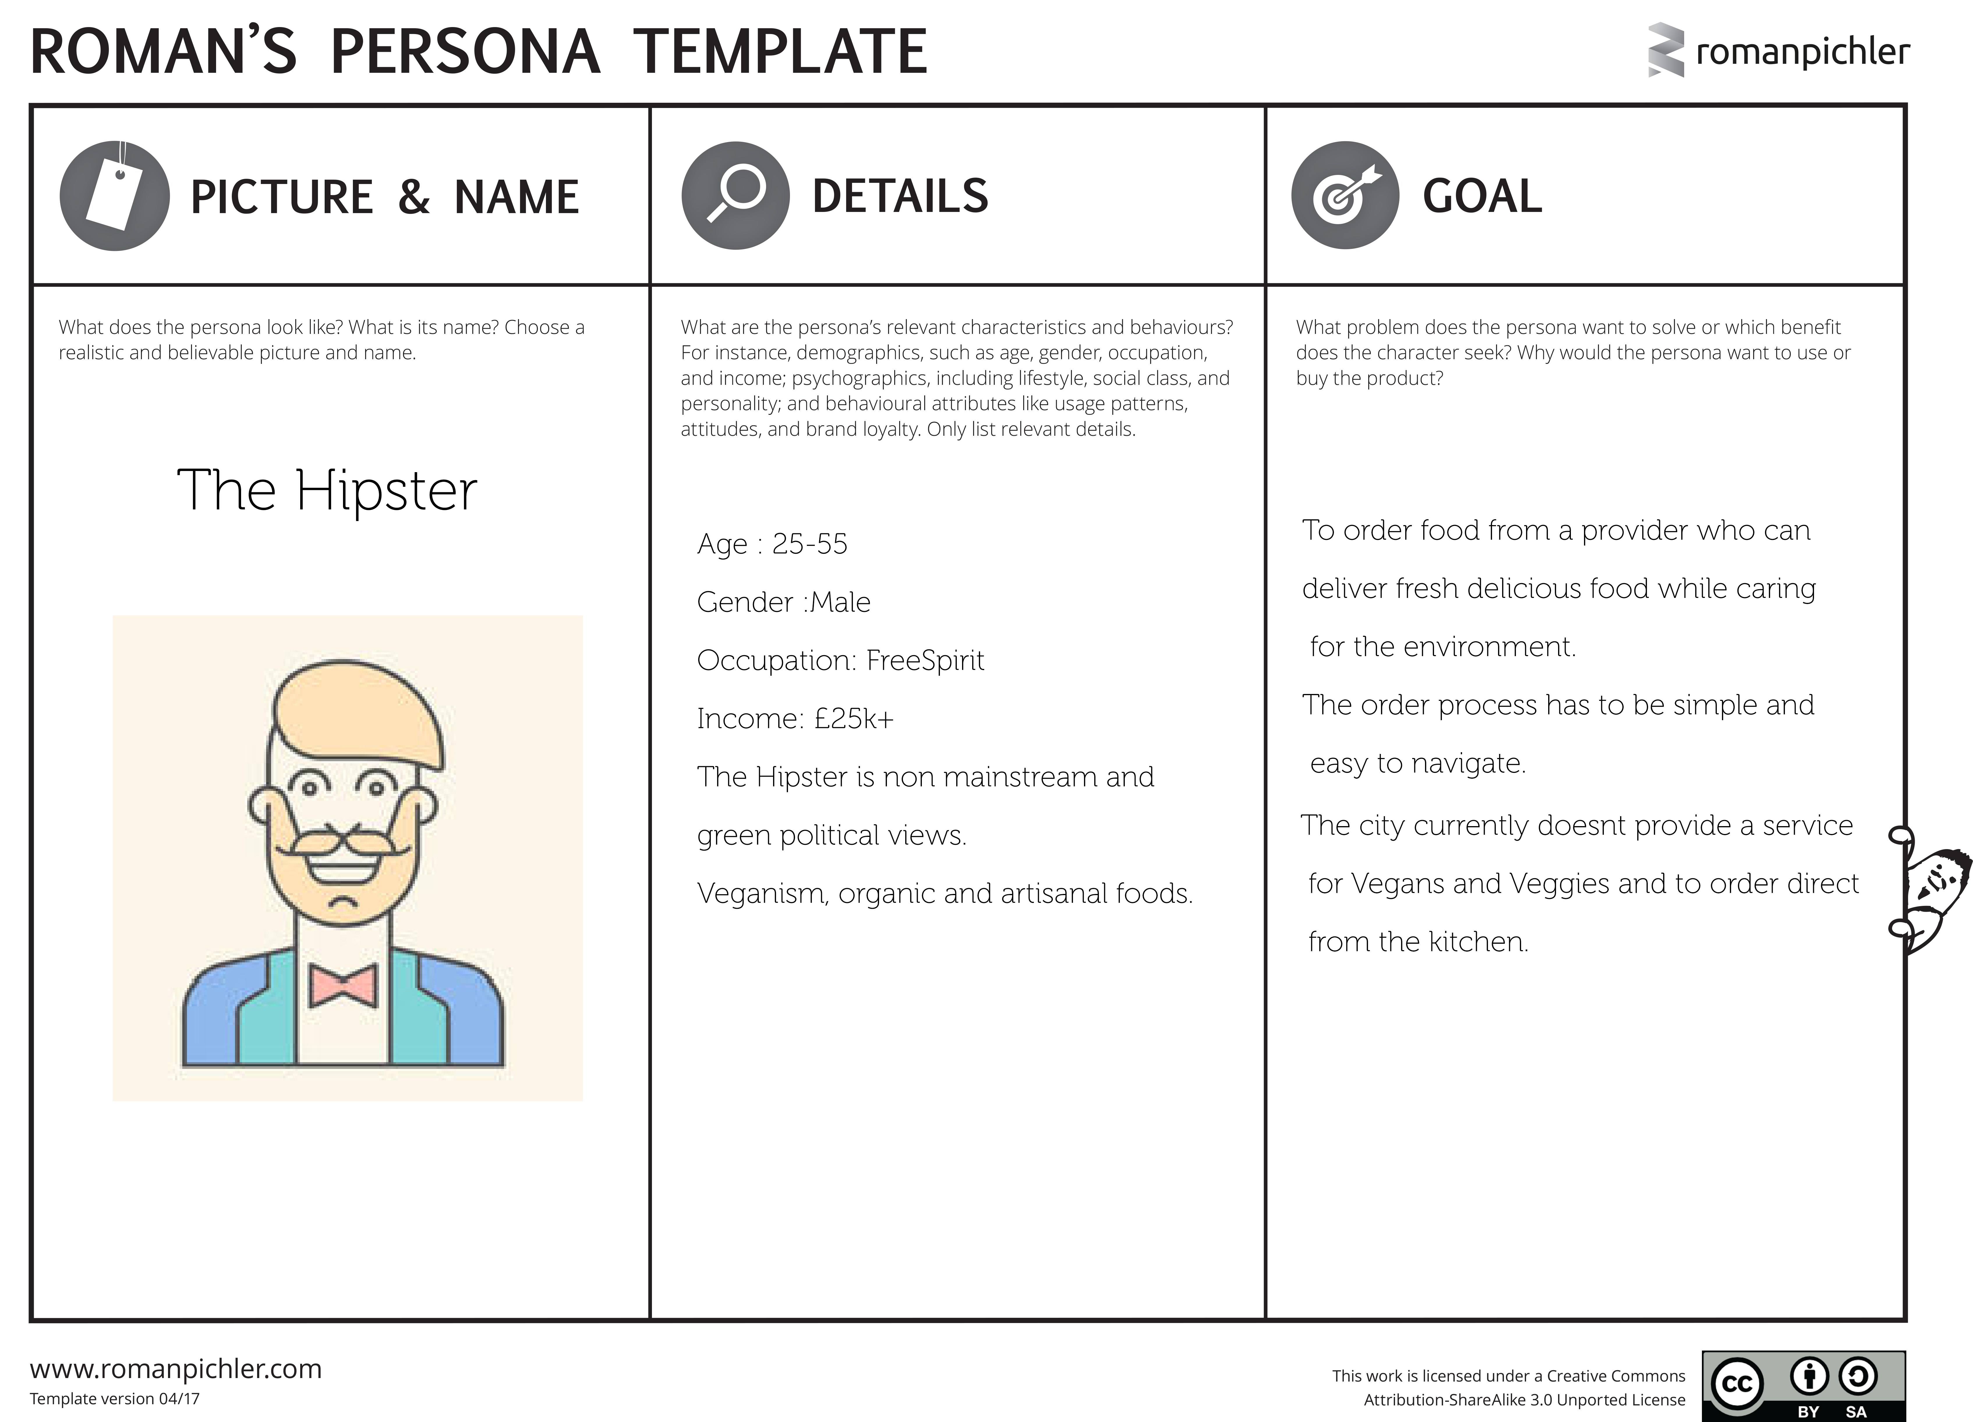

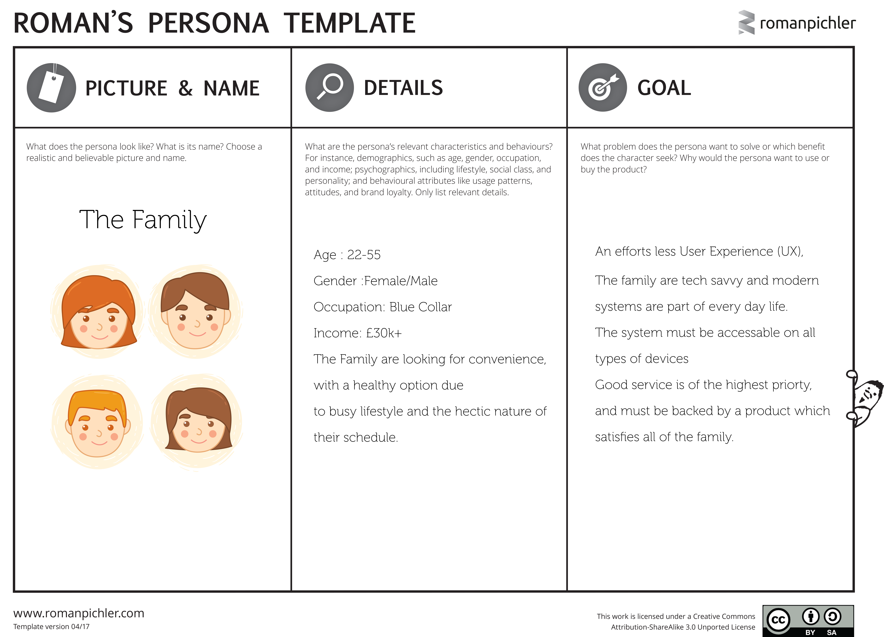

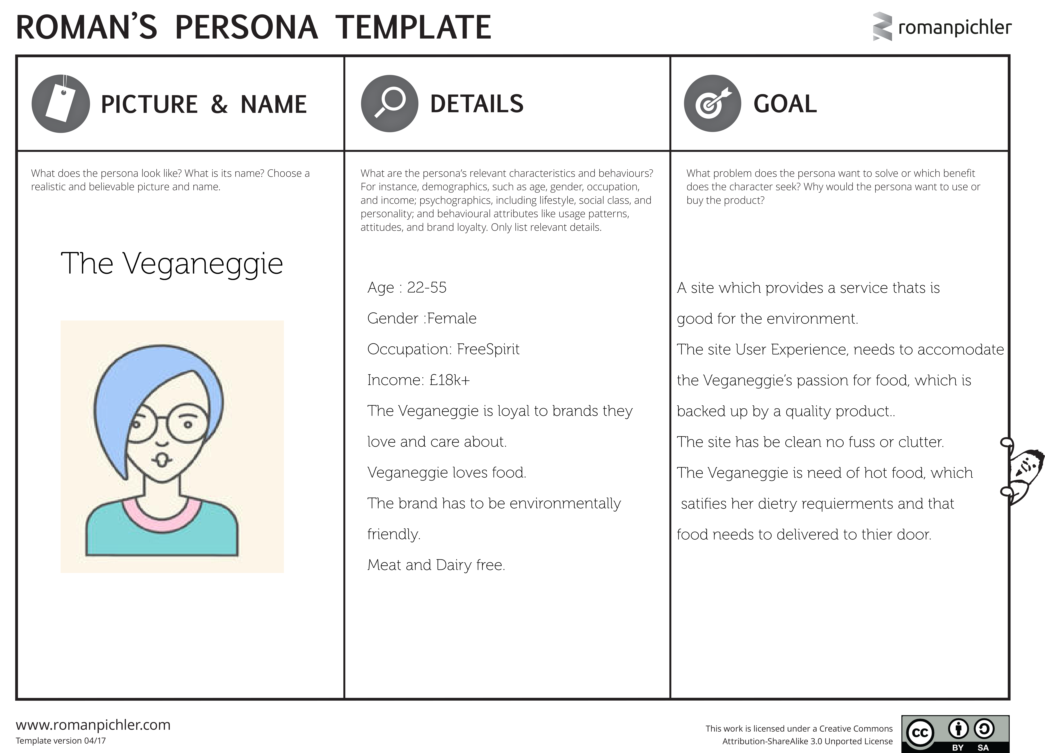

# The Goals…

To build a Website which will manage the orders, user accounts, promotions and discounts. The site will consist of a Landing page, menu pages, an about page and the standard contact form and a download page to gain access to the mobile app and special discounts.

The site has to be clean, with fresh colors. Easy to navigate, with friendly fonts and an order process which is seamless and user friendly.

The user will never feel lost within UX with will give clear and concise guidance all the way through the ordering process.

# The Competition

Competition from delivery of hot meals comes from the Big 3. Just Eat, Deliveroo and Hungry House. While vegan and vegetarian food can be ordered form companies who cook and freeze the meals for later use. Meat Free meals & Allplants are two of the biggest players on the web.

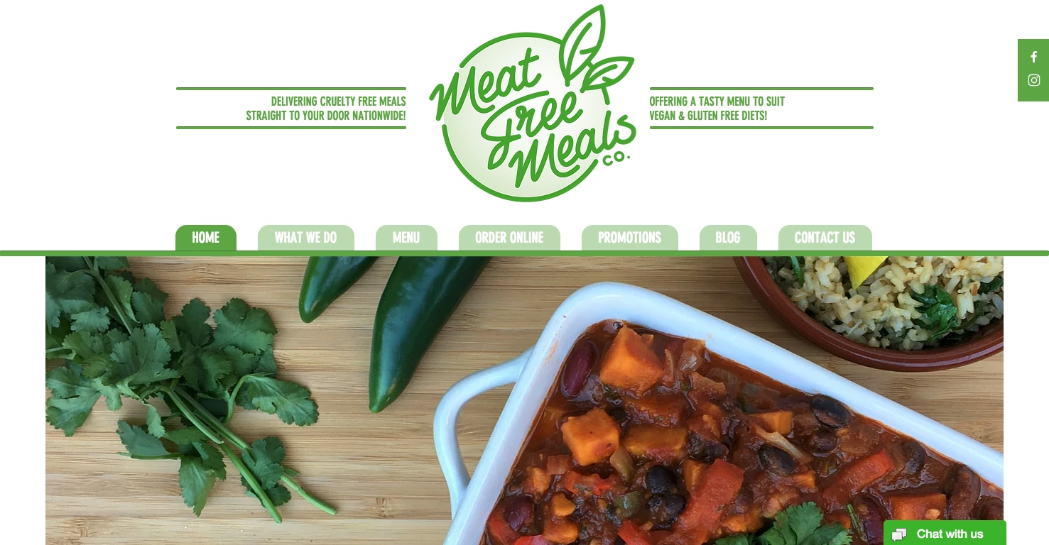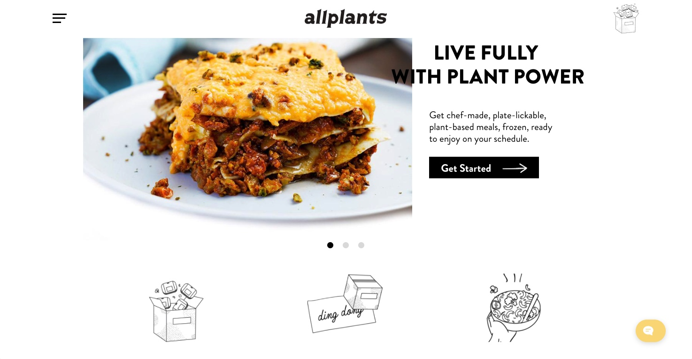

<https://www.meatfreemeals.co.uk/> <https://allplants.com/>

Meat free meals is easy on the eye, it’s a one-page, smooth scrolling site, which is feature I really like. However, for the purpose of the assignment. Multiple pages will be designed. The site is pleasant on the with green tones and white. The Navigation is well place and nicely designed.

All plants.com is big, bold, and very easy to navigate. I like the layout of the menu page it easy for the user to make their way around the order system. The black and white color scheme gives simple and clear UX. It has some design flourishes which are very cool.

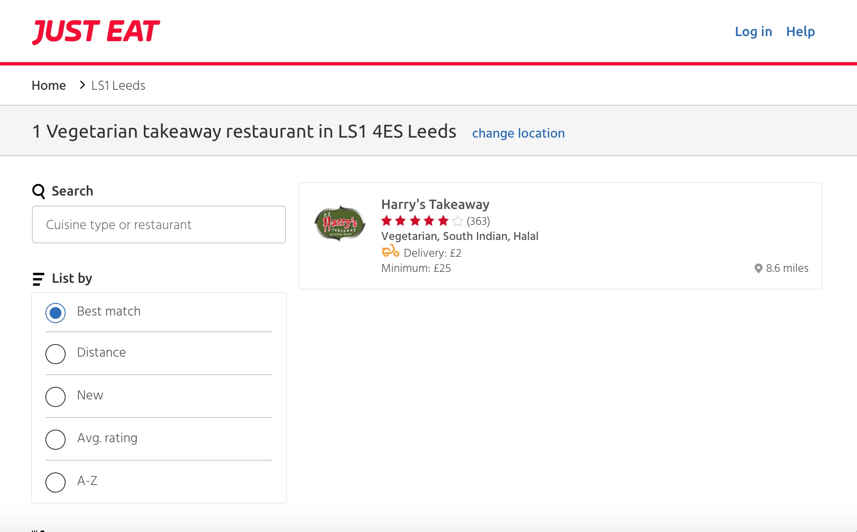

Just Eat – [www.just-eat.com](http://www.just-eat.com)

Just Eat only offered one restaurant with vegetarian option. However the UX is smooth, the customer is aware of where they are on the site at all times.

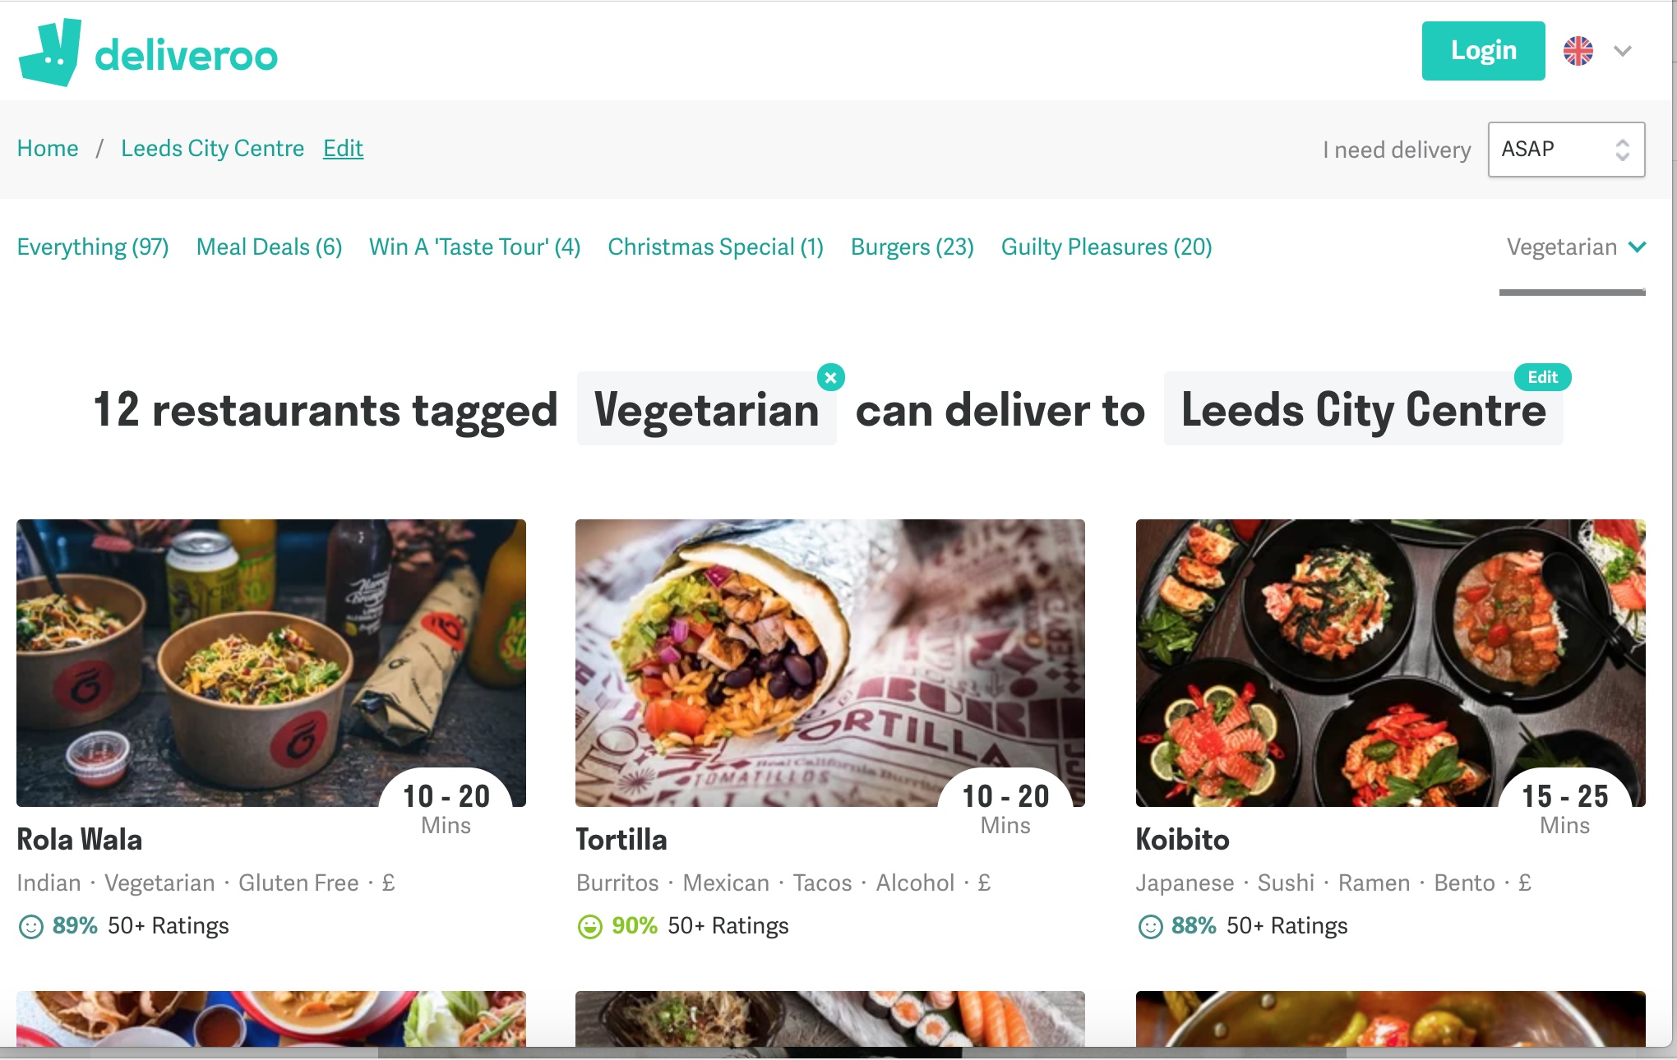

Deliveroo – [www.deliveroo.com](http://www.deliveroo.com)

Deliveroo had the most connections to Vegetarian meals. The images are cool and trendy. This makes the UI stand out from the other and is more appealing to the audience I aim to target.

Hungry House – [www.hungryhouse.com](http://www.hungryhouse.com)

Hungry House had one provider of Vegetarian meals within the geographical area.

The UX at Hungry House seemed off in regards to font size choices, particularly the menu page.

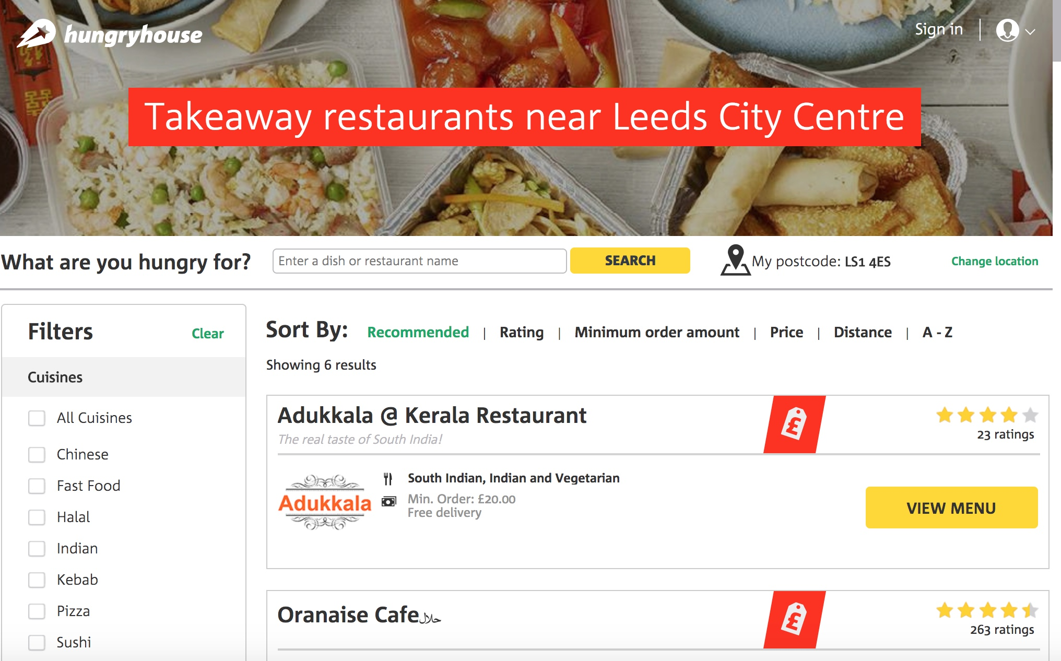

# Styling

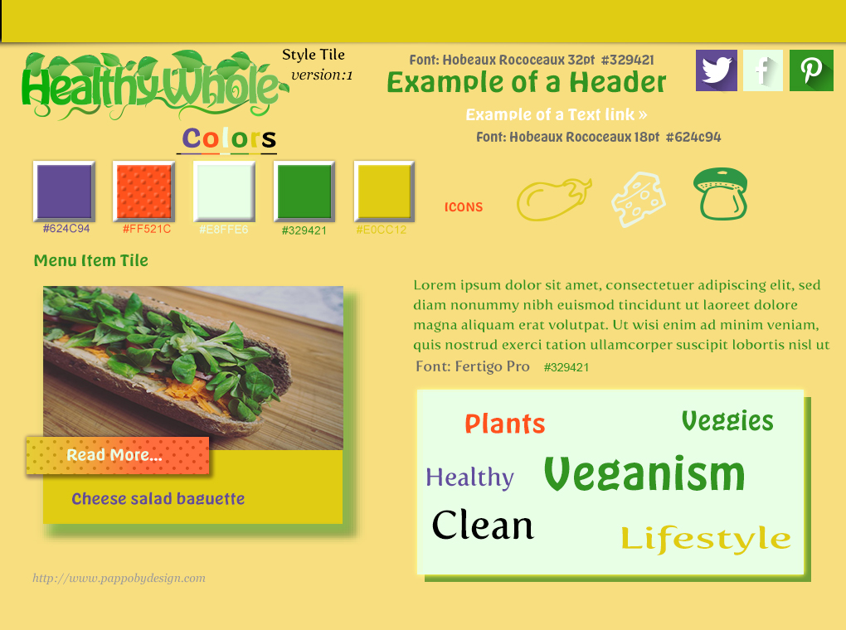

The Rainbow style tile was intended to shoe a rainbow of color.

The logo has several colors combined which doesn’t work very well for web logo’s.

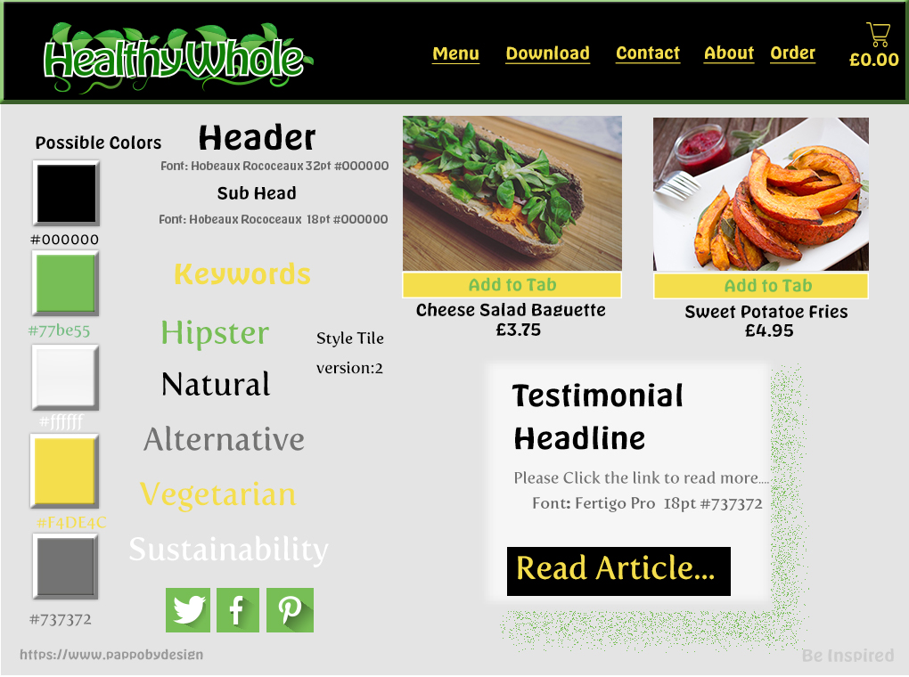

The Black & Grey style tile seem popular when gathering feedback.

I further advanced this style with the final tile.

The some of the color doesn’t fit the clean crisp image I need to portray.

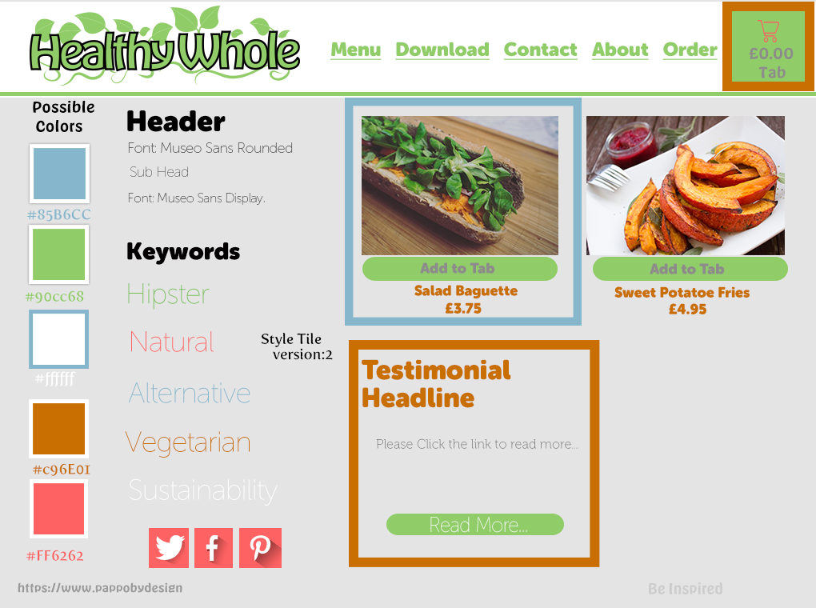

# Wire Framing

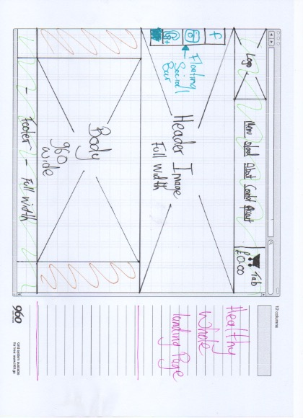

Healthy Whole Landing Page

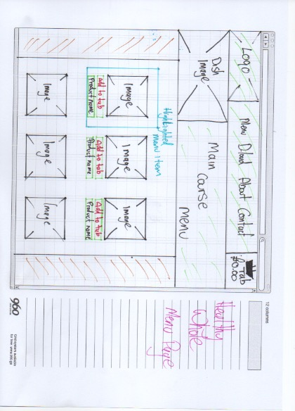

Healthy Whole Menu Page

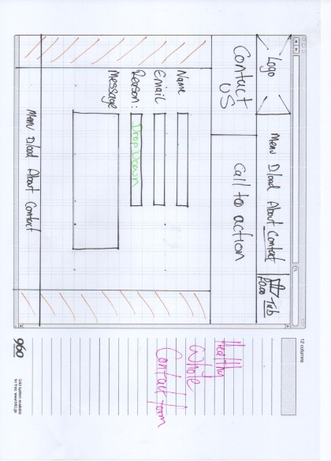

Healthy Whole Form Page

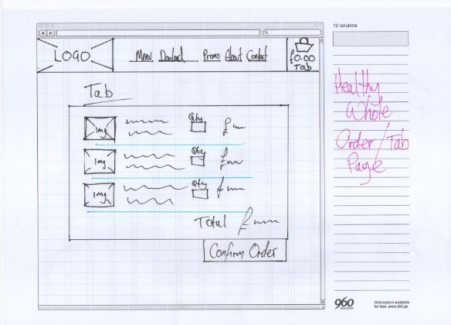

Healthy Whole Tab Page

# Mock Up – Desktop, Landing Page

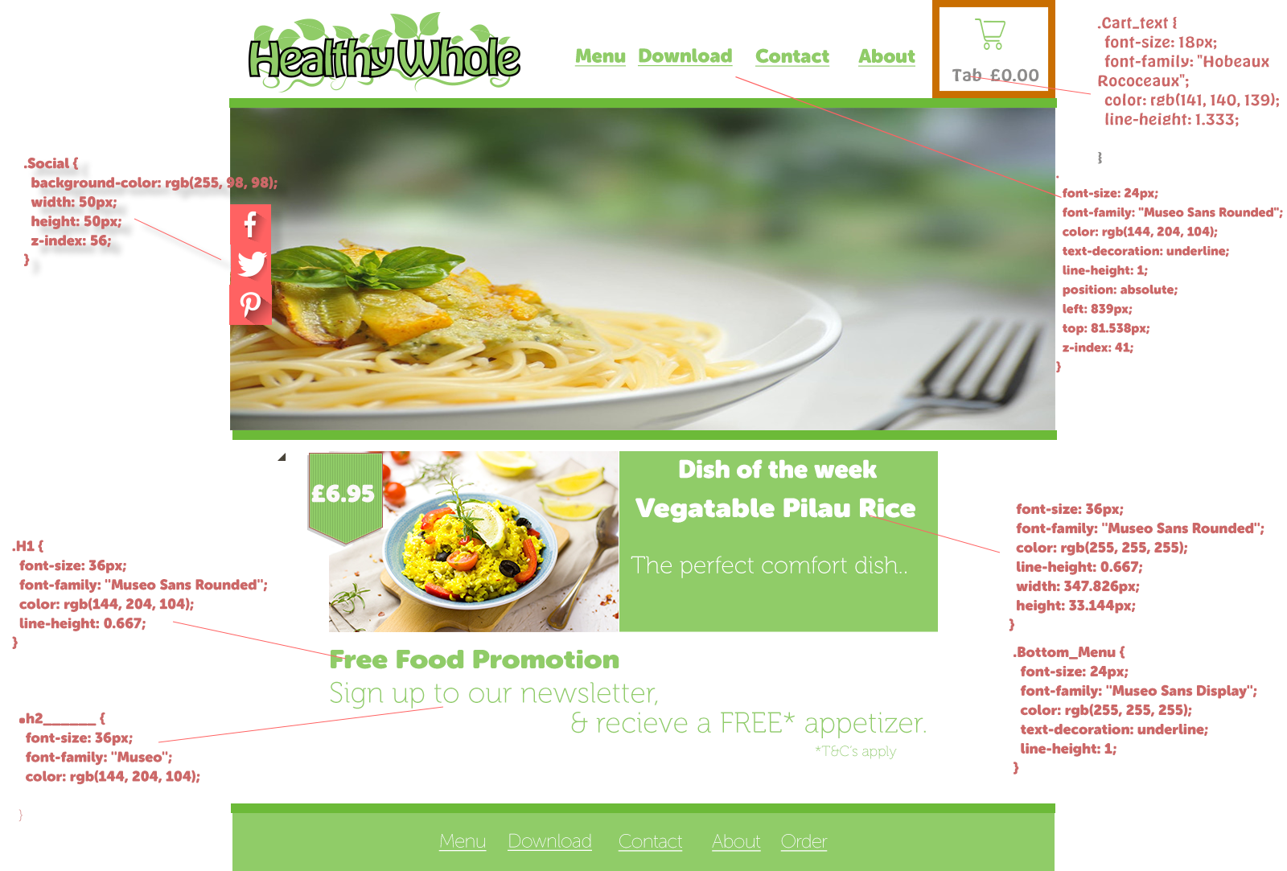

# ­­­Menu Page

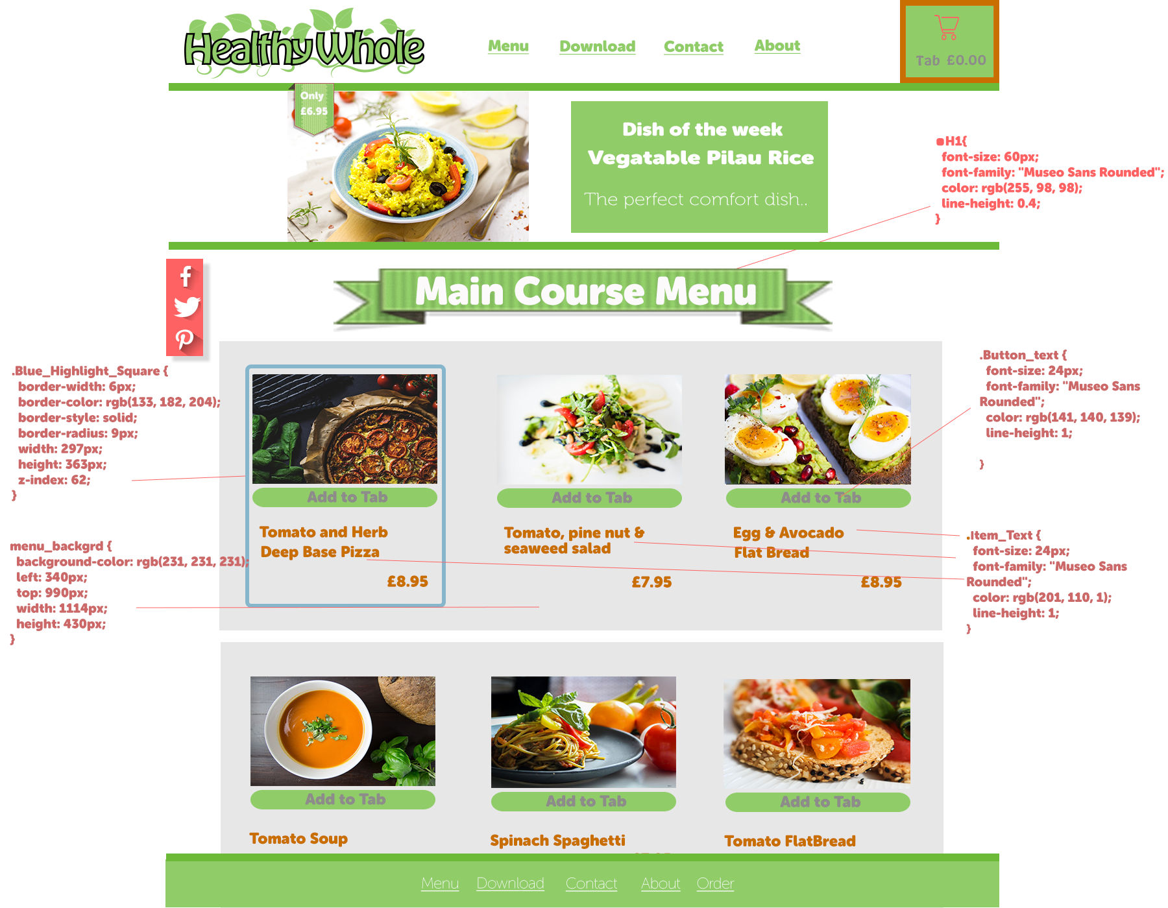

# Desktop -Mac Mock-Up

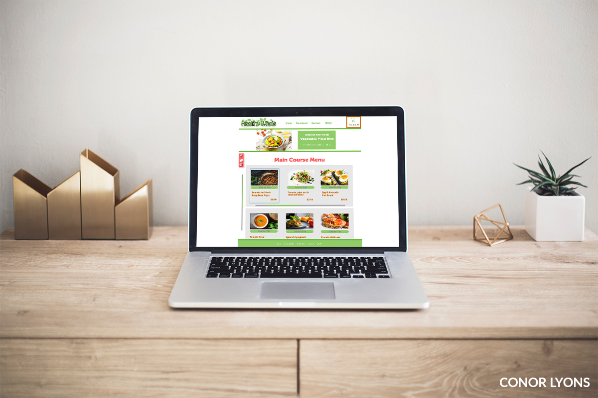

# Tab Page



# Contact Page

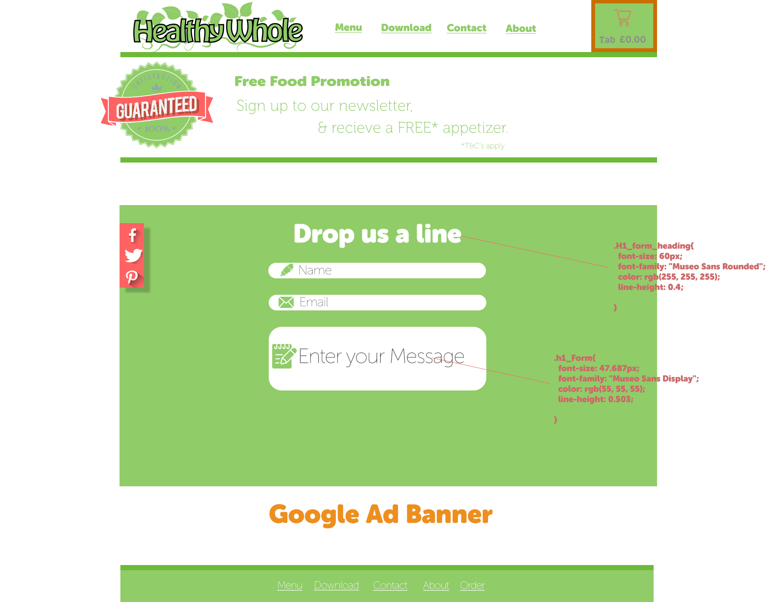

# Mock Up – Mobile­­­

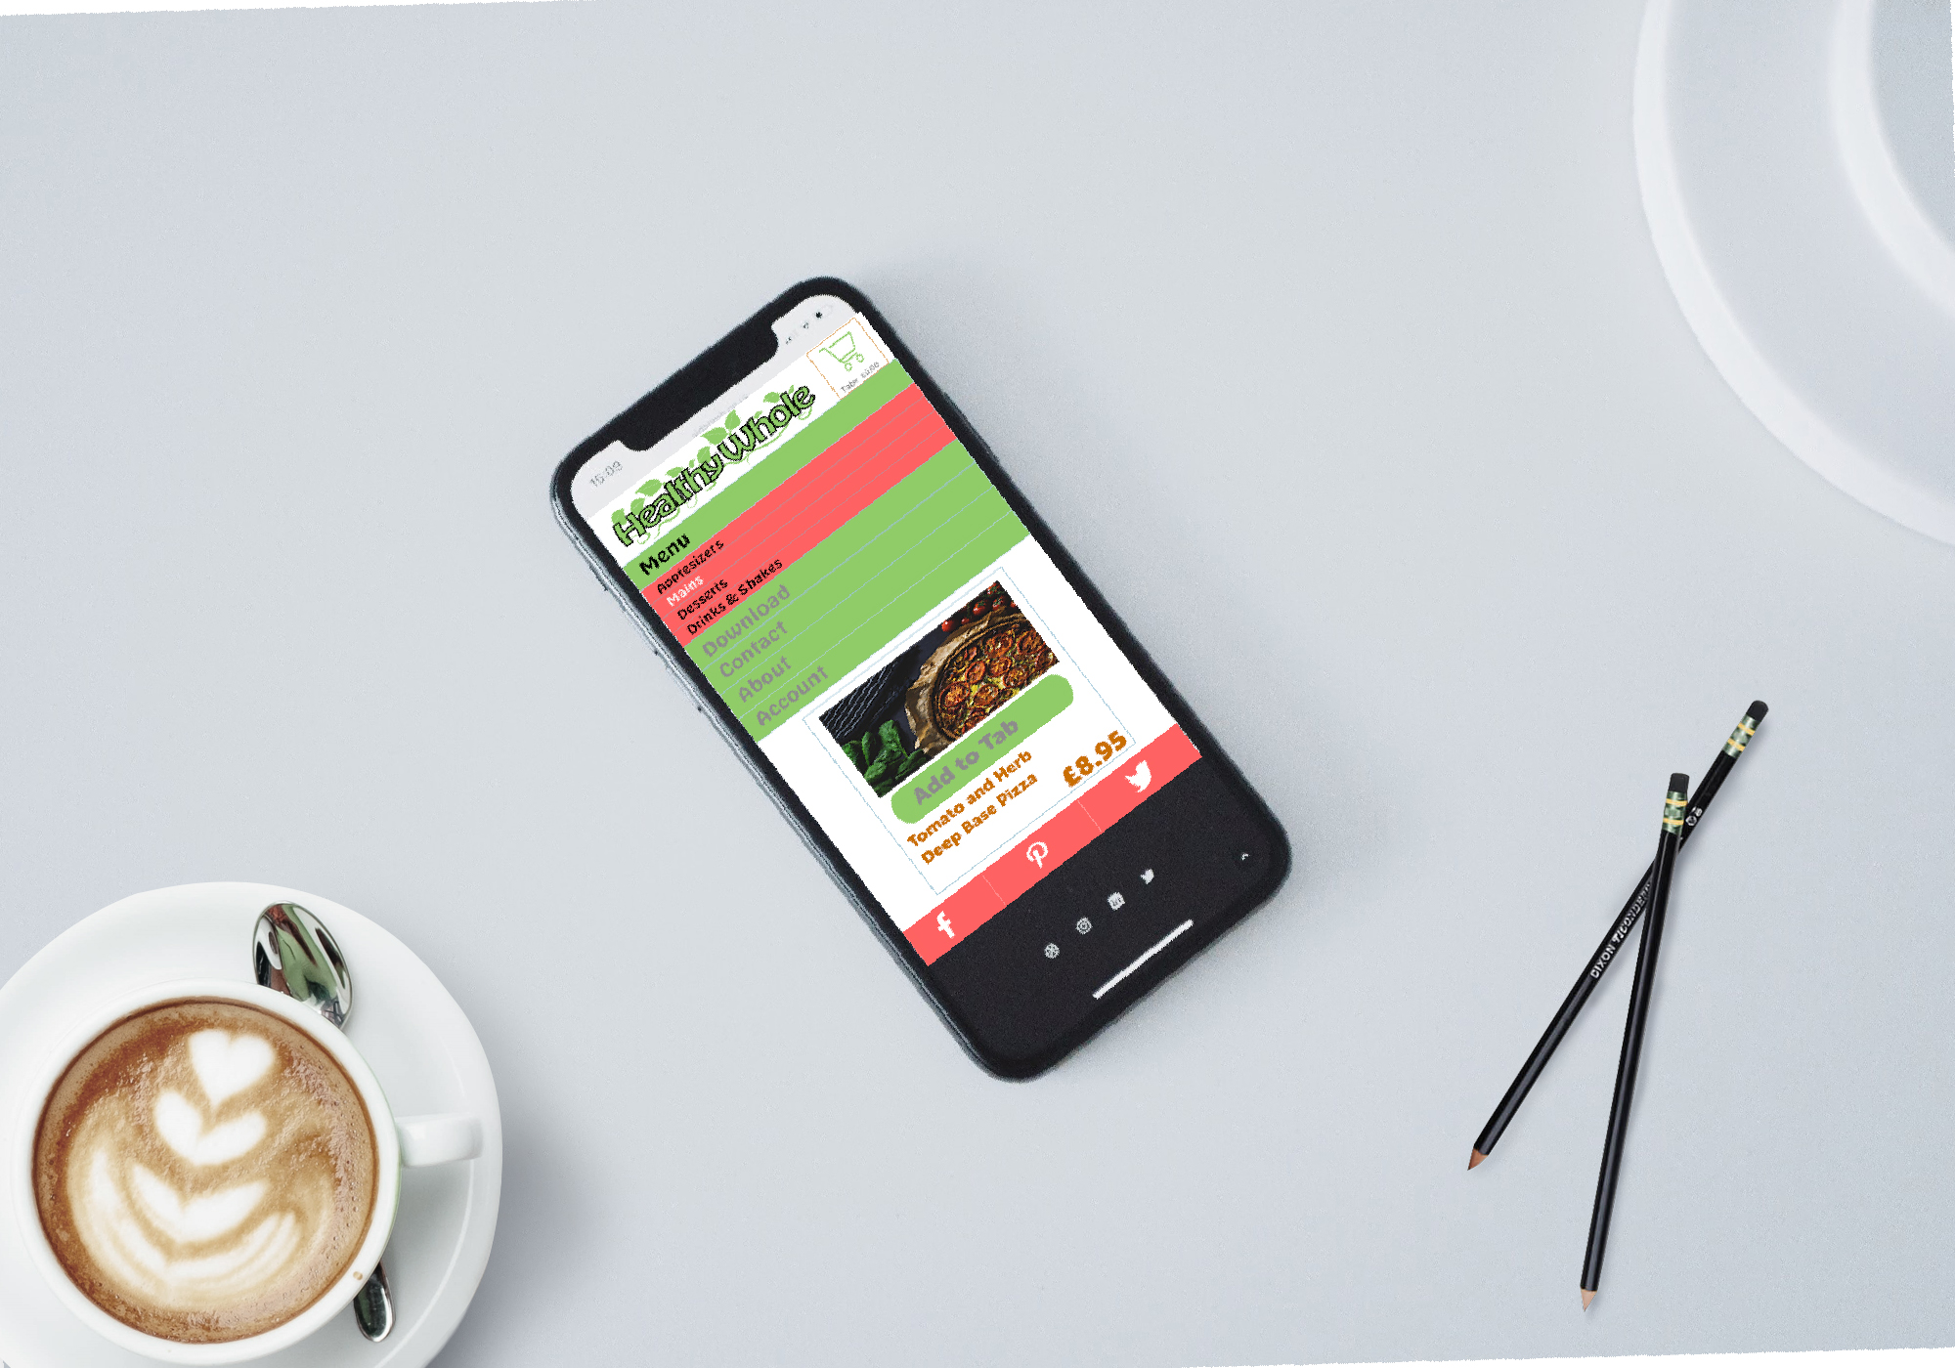

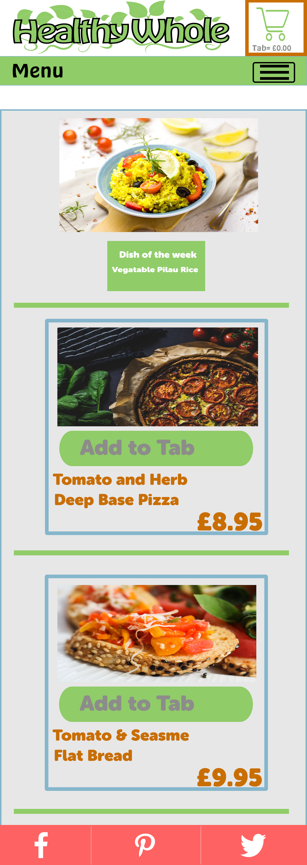

# Feedback

Following feedback from both my peers and Jon Walters. The styles changed drastically. The Logo was reduced to 2 colors from 5.

The style tile feedback favored the Black and Grey, The Green and White was the personal favorite, so I blended the two which gives­­ the final result.

Adding the grey background to the white of the menu items gives contrast to the page. The shopping cart needed more contrast so I added a solid color following feedback from Jon Walters.

# Reflection

All in all, I think the design wouldn’t be out of place in the current market. A little more design flair would have helped, however this will come with practice. I’m happy with effort.

# Bibliography

**There are no sources in the current document.**

<https://www.pexels.com/photo/baguette-blur-bread-cheese-208485/>

Style Tile 1

<https://www.pexels.com/photo/crust-delicious-dinner-dish-568370/>

Menu 1

<https://www.pexels.com/photo/blur-bowl-close-up-cook-461326/>

Rice Bowl Order Tab

<https://www.pexels.com/photo/baked-bread-close-up-cooking-236780/>

Tomato Bread

<https://www.pexels.com/photo/pexels-photo-568370/>

Pizza https://www.pexels.com/photo/

<https://www.pexels.com/photo/pexels-photo-461326.jpeg>

Pilau Rice

<https://www.pexels.com/photo/pexels-photo-236780.jpeg>

Sweet Potatoes